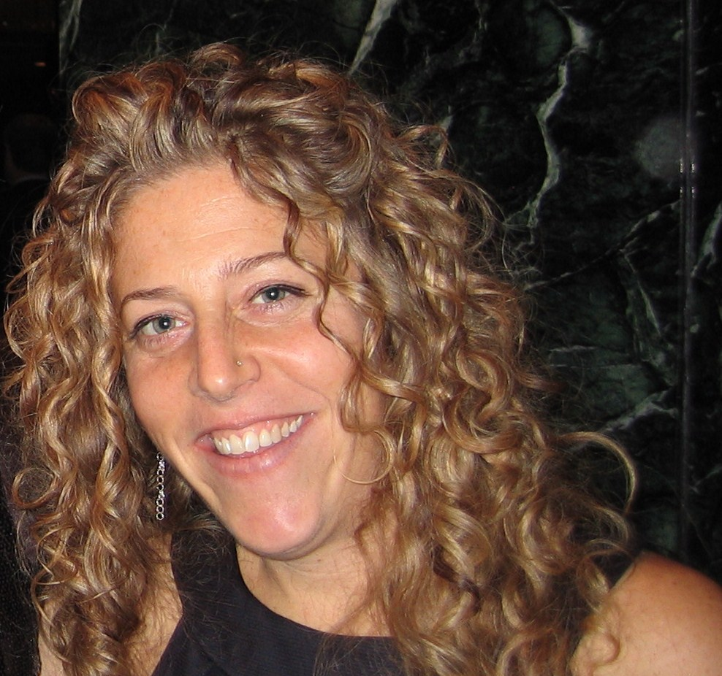
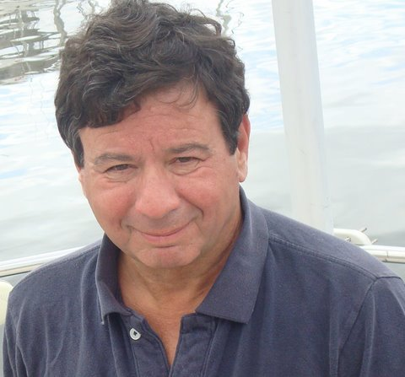
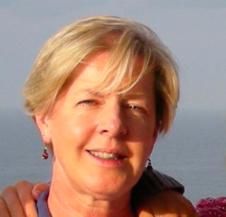


Getting to the Heart of Money

Nancy Fritsche Eagan, Host, Caller and Consultant, People Potential and All My Sisters, Art of Hosting Practitioner. I founded People Potential and All My Sisters with the focus of supporting shared governance, social justice and intentional change and growth within families, schools, communities and organizations. My emerging work focuses on local and global women’s economic and leadership development; Intergeneration and shared governance models; education reform and sustainable community development. Some of my current collaborations include leadership development at the NYC Citywide Training Center and at the Children’s Aid Society; organizational development and implementation of The Sanctuary Model at Good Shepherd Services; promoting youth development and collaborative leaderip in NYC schools; and supporting Handcrafting Justice and other women’s economic projects. I am coordinating women’s initiative at the Berkana Institute and use the tools and principles of the Art of Hosting in my work. www.peoplepotential.org www.allmysisters.org

Martin Siesta serves on the Board of the Berkana Institute and is a Steward and Practitioner of the Art of Hosting. He works with businesses and non profit organizations in hosting conversations that matter, leadership development and building capacity within community based organizations. Martin’s passion is organizing, designing, and hosting inspired spaces –dialogues, strategic change processes, circle councils, networked organizations- each in support of life-affirming leadership, interactive learning, organizational and social transformation and self-organization. He provides holistic financial planning, for individuals and organizations, linking values with money. He is associated with the Kinder Institute as a senior trainer preparing life planners. He has served on the Financial Planning Association’s National Board and serves on the CFP Commission on Discipline and Ethics.

Tami L. Farber, MSW, President of Together Leading the Future, Inc. (TLF) and a current PhD candidate in social welfare at CUNY Graduate Center, brings you more than twenty years of experience in the fields of child/youth development, education, organizational leadership and community organizing for national and international government and non-governmental organizations, schools and the for-profit sector. Tami’s ongoing work brings her to schools, governmental and inter-governmental organizations, community based organizations and companies running programs, organizing and facilitating small and large scale conferences, developing programs and curriculum and leading trainings and workshops for young people, adult professionals and parents. Tami’s work is rooted in a social justice and an anti-oppression/human rights framework and she uses participatory methods to engage communities to work towards collective change.
mARch 24th-25th 2011

Registration deadline: March 14

Location: 12 West 12th Street- New York, NY
Time: 9 AM- 5 PM both days
For more information contact:
Martin Siesta
Msiesta2@aol.com
973-763-6902
www.berkana.org

Details:
Includes training materials, light breakfast and lunch
Registration is through the Berkana Institute
$250

Costs

Contact

Registration
APPROACHES FROM WHICH WE DRAW INSPIRATION
- World Café
- U-Process
- Appreciative Inquiry
- Storytelling
- Circle Practice
WE WILL CO-CREATE
- Our learning will grow out of participant contributions and presence
- We will support each other as co-learners
- We will learn by observation, experience and practice
- We will use interactive processes to build a safe, challenging and inspiring learning environment

